PROJECT DEVELOPMENT DELIVERY OF SPRINT-2

TEAM ID | PNT2022TMID53640
PROJECT NAME | SMART SOLUTIONS FOR
 | RAILWAYS

Proposed architecture for smart track monitoring system.
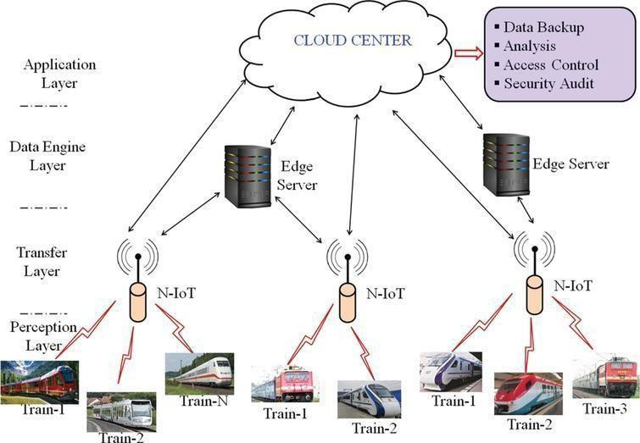

Structural health monitoring of railway tracks using IOT-based multi robot system:
